**Module: 1 ->Assignment**

* **What is SDLC ?**
* SDLC ( Software Development Life Cycle )
* SDLC is a structure imposed on the development of a software product that defines the process for planning, implementation, testing, documentation, deployment, and on-going maintenance and support. There are a number of different development models.
* **What is software testing?**
* Software Testing is a process used to identify the correctness, completeness, and quality of developed computer software.
* **What is agile methodology?**
* Agile model believes that every project needs to be handled differently and the existing methods need to be tailored to best suit the project requirements. In agile the tasks are divided to time boxes (small time frames) to deliver specific features for a release.
* **What is SRS ?**
* SRS (Software Requirement Specification)
* Software requirements specification (SRS) is a complete description of behaviour of the system to be developed.
* **What is oops ?**
* “ object oriented programming “
* Identifying objects and assigning responsibilities to these objects.
* **Write Basic Concepts of oops**
* Object
* Class
* Encapsulation
* Inheritance
* Polymorphism
* Abstraction
* **What is object ?**
* “ It is an instance/example/part of a class. “
* An object represents an individual, identifiable item, unit, or entity, either real or abstract, with a well-defined role in the problem domain.
* **What is class ?**
* “ Class is a blueprint for an object. “
* Class can have many objects but object may only relate to a single class.
* **What is encapsulation ?**
* “ Wrapping up of data into a single unit “.
* Encapsulation is the practice of including in an object everything it needs hidden from other objects. The internal state is usually not accessible by other objects.
* **What is inheritance ?**
* “ Ability to adapt behaviour of parent class to child class “
* Inheritance means that one class inherits the characteristics of another class. This is also called a relationship
* **What is polymorphism ?**
* “ Having Many Forms. “
* It allows different objects to respond to the same message in different ways, the response specific to the type of the object.
* **Draw Usecase on Online book shopping**

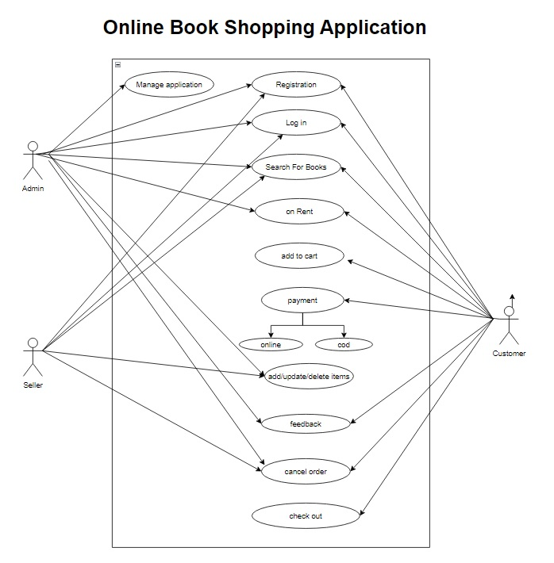

* **Draw Usecase on online bill payment system (paytm)**

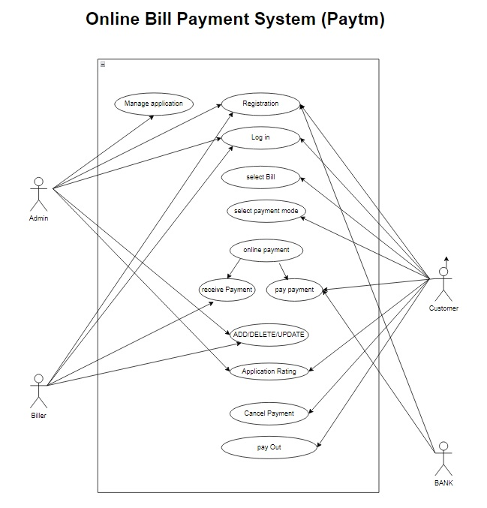

* **Write SDLC phases with basic introduction**
* **Requirement Gathering :**
* Establish Customer Needs.
* There are two types of requirement
* Functional & Non- Functional
* **Analysis :**
* Model And Specify the requirements- “What”
* **Design :**
* Model And Specify a Solution – “Why”
* **Implementation :**
* Construct a Solution In Software
* **Testing :**
* Validate the solution against the requirements
* **Maintenance :**
* Repair defects and adapt the solution to the new requirements
* **Explain Phases of the waterfall model**
* Requirement collection
* Analysis
* Design
* Implementation
* Testing
* Maintenance
  + **Write phases of spiral model**
* Planning
* Risk Analysis
* Engineering
* Customer Evolution
  + **Write agile manifesto principles**
    - Customer collaboration
    - Working model
    - Individual & Interaction
    - Responding to Change
  + **Explain working methodology of agile model and also write pros and cons.**
* Agile SDLC model is a combination of iterative and incremental process models with focus on process adaptability and customer satisfaction by rapid delivery of working software product
* **Agile model Pros**.
* Is a very realistic approach to software development
* Promotes teamwork and cross training.
* Functionality can be developed rapidly and demonstrated.
* Resource requirements are minimum
* Suitable for fixed or changing requirements.
* Enables concurrent development and delivery within an overall planned context.
* Little or no planning required.
* Easy to manage.
* Gives flexibility to developers.
* **Agile model Cons.**
* Not suitable for handling complex dependencies.
* More risk of sustainability, maintainability and extensibility.
* An overall plan, an agile leader and agile PM practice is a must without which it will not work.
* Strict delivery management dictates the scope, functionality to be delivered, and adjustments to meet the deadlines.
* Depends heavily on customer interaction, so if customer is not clear, team can be driven in the wrong direction.
* There is very high individual dependency, since there is minimum documentation generated.
* Transfer of technology to new team members may be quite challenging due to lack of documentation.
  + **Draw use-case on Online shopping product using COD.**

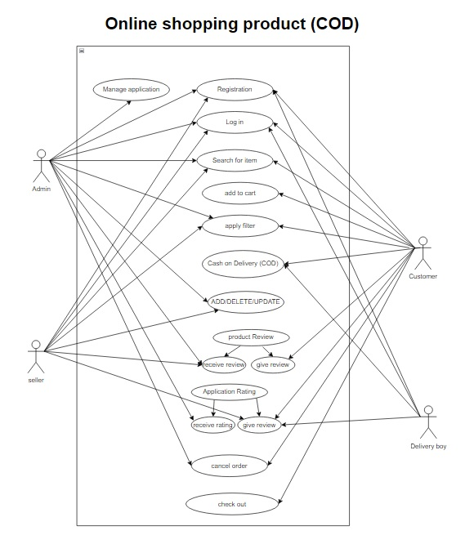

* + **Draw use-case on Online shopping product using payment gateway.**

